**R Notebooks: Helpful hints**

* The first part of the document is called the YAML (Yet Another Markup Language). This contains metadata about the file. You can give the document a title and author. As you export your file to different formats, those will display in the output section.  
  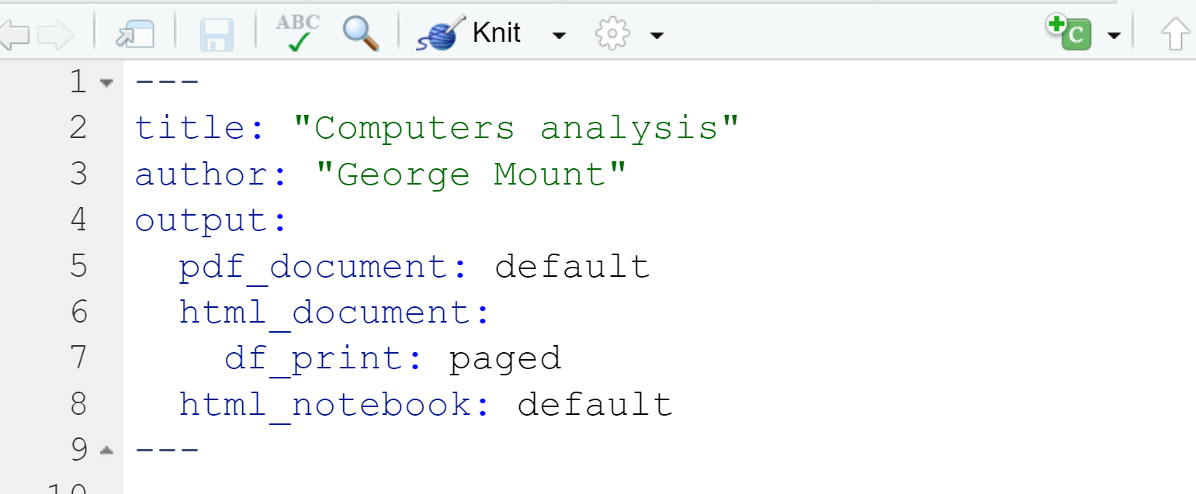
* As you insert headers into the document, you will see button to the left to expand/contract the file:  
  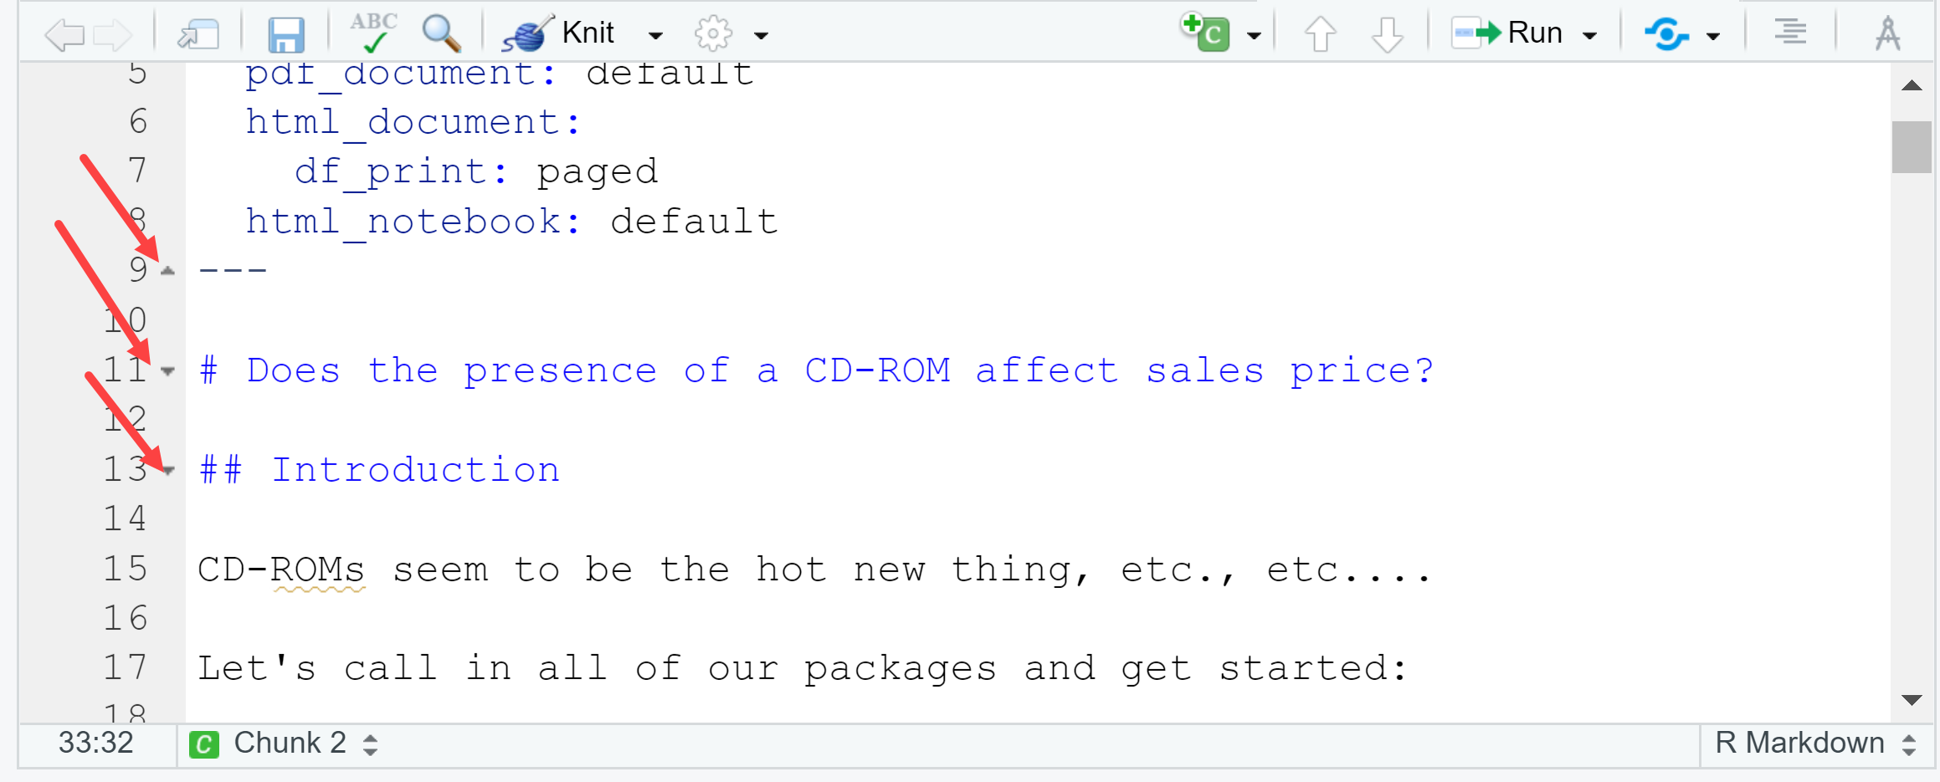
* The C and Run icons will let you, among other things, insert and run chunks, respectively:  
  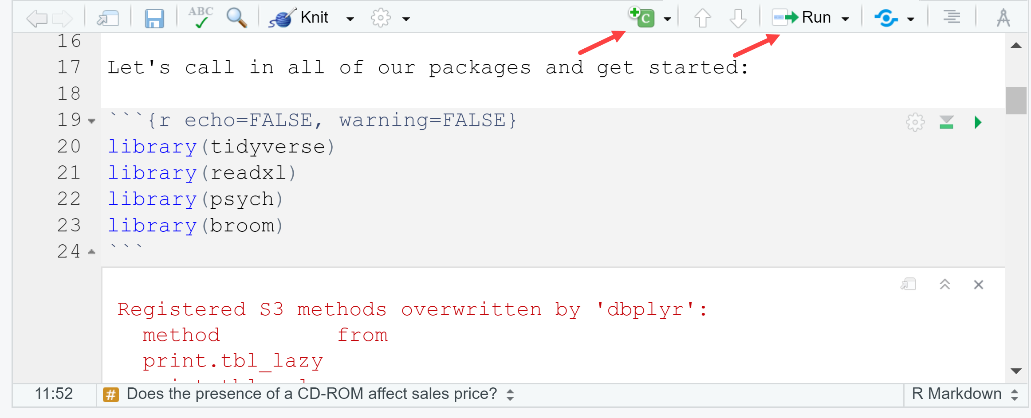
* You can customize the settings of chunks; we’ll use the following (as in previous screenshot). See more at the [official cheat sheet](https://rmarkdown.rstudio.com/lesson-15.html):
  + echo = FALSE will stop code from being shown in the output document
  + warning = FALSE will stop warnings from being shown in document
  + include = FALSE will run the chunk, but no code or output will be shown in the document.
  + message = FALSE will stop any messages being shown in the output document
* To view a preview of the document side-by-side with the R Notebook, click on the gearwheel of your document and select “Preview in Viewer Pane.” Then click “Preview” above your doc. The preview will show up in the Viewer pane.
  + This preview does not update on its own; to see subsequent changes to the doc, click Preview again or save the doc.   
    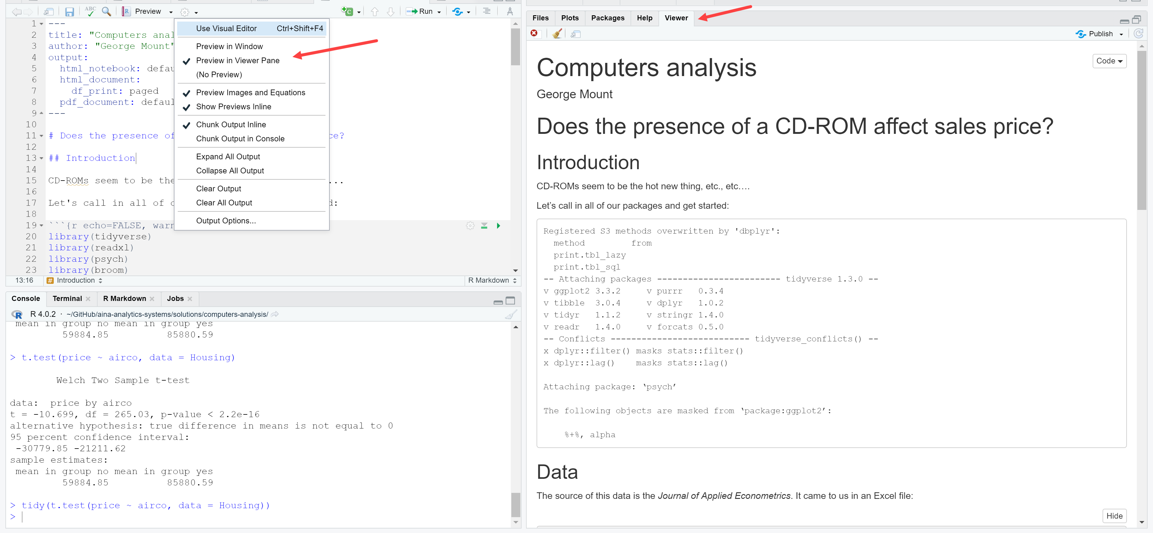
* When you are ready to export the document, click under Preview > Knit to PDF (for example). You will see a log of the export process in the R Markdown tab. The document by default will be exported to wherever your R Notebook is.   
  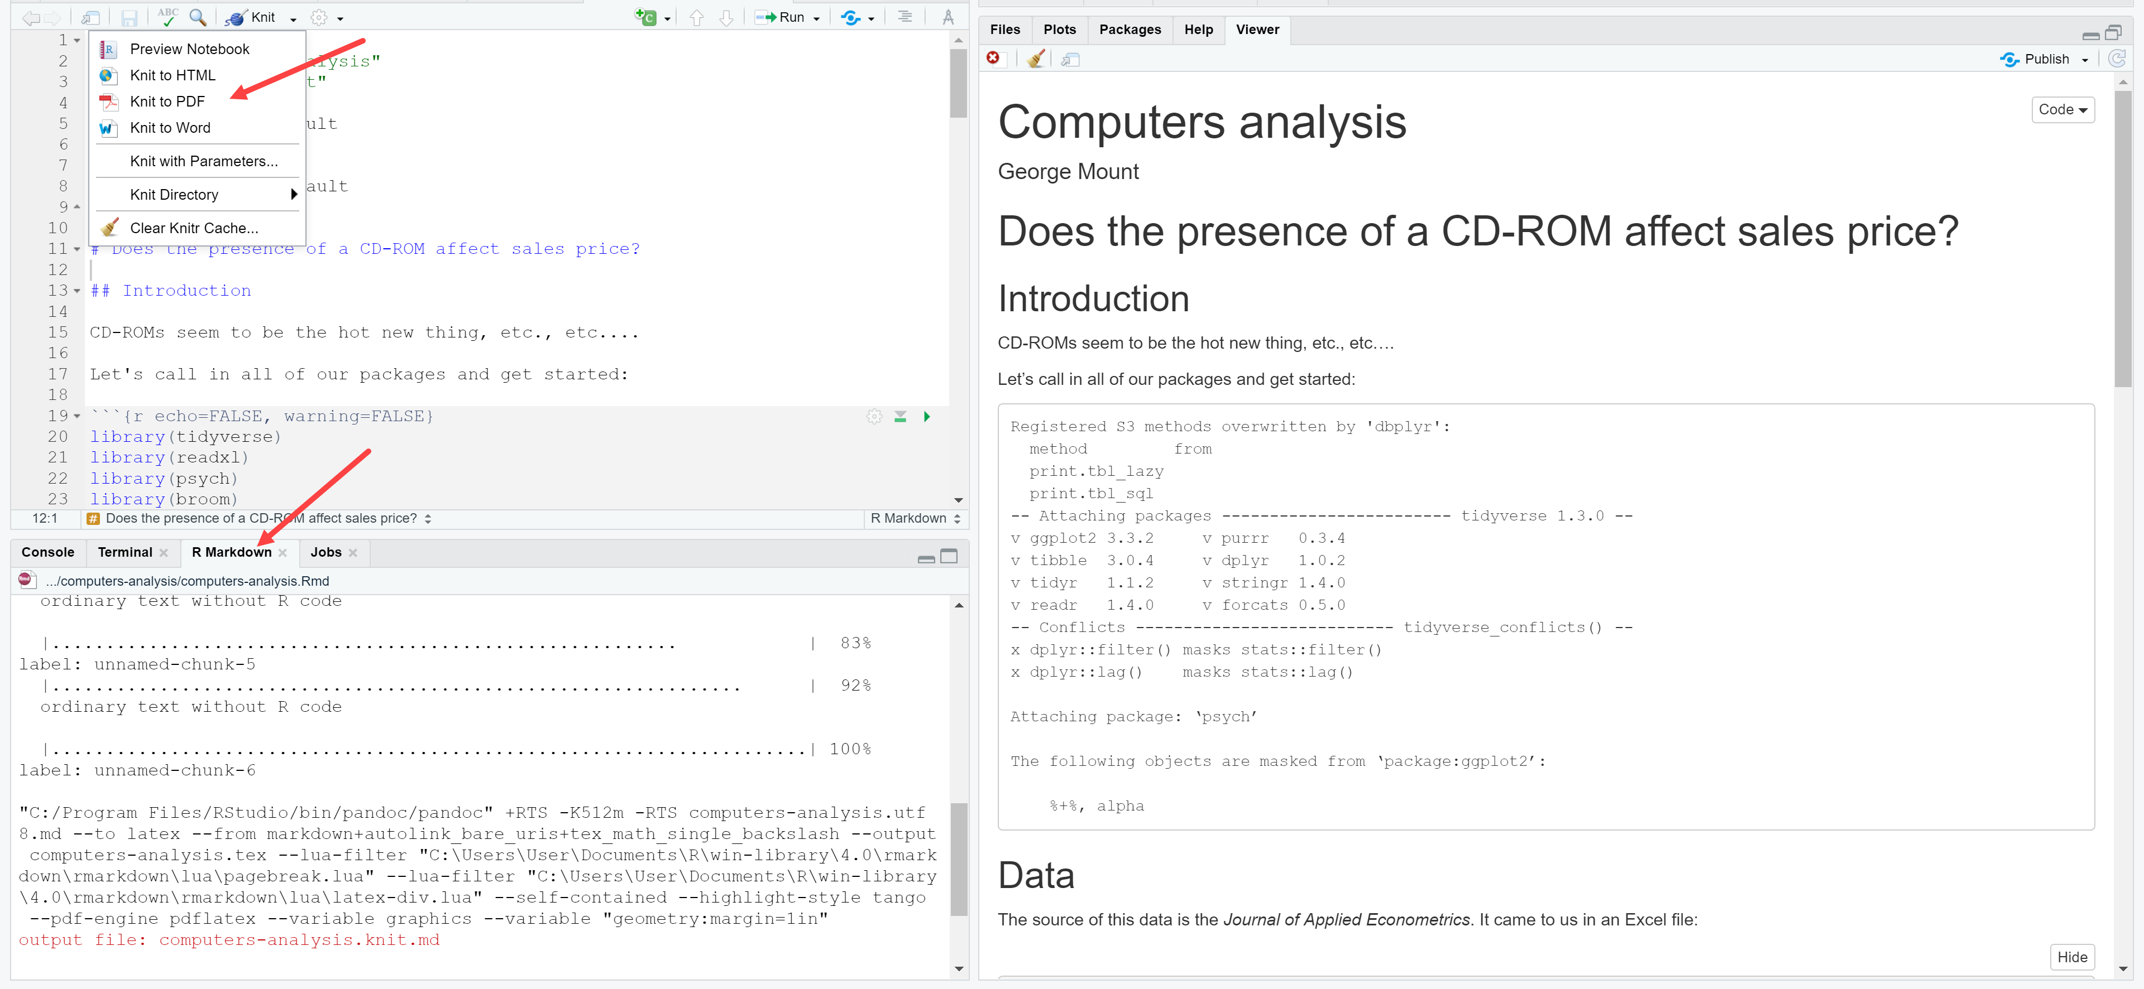
* The tidy() function can be used to present the result of many statistical tests in a more tabular format:  
  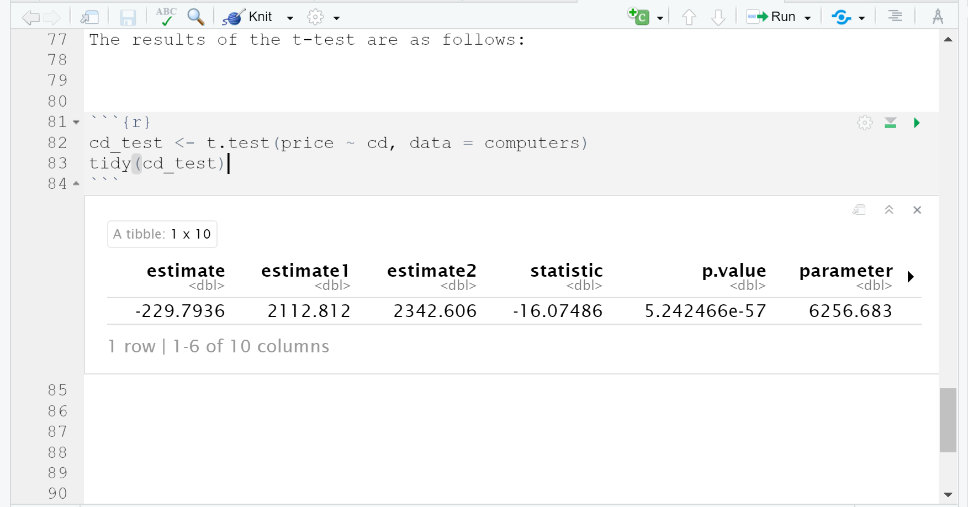
* You can use in-line blocks for dynamically-rendered text using `r objectname` like so:  
  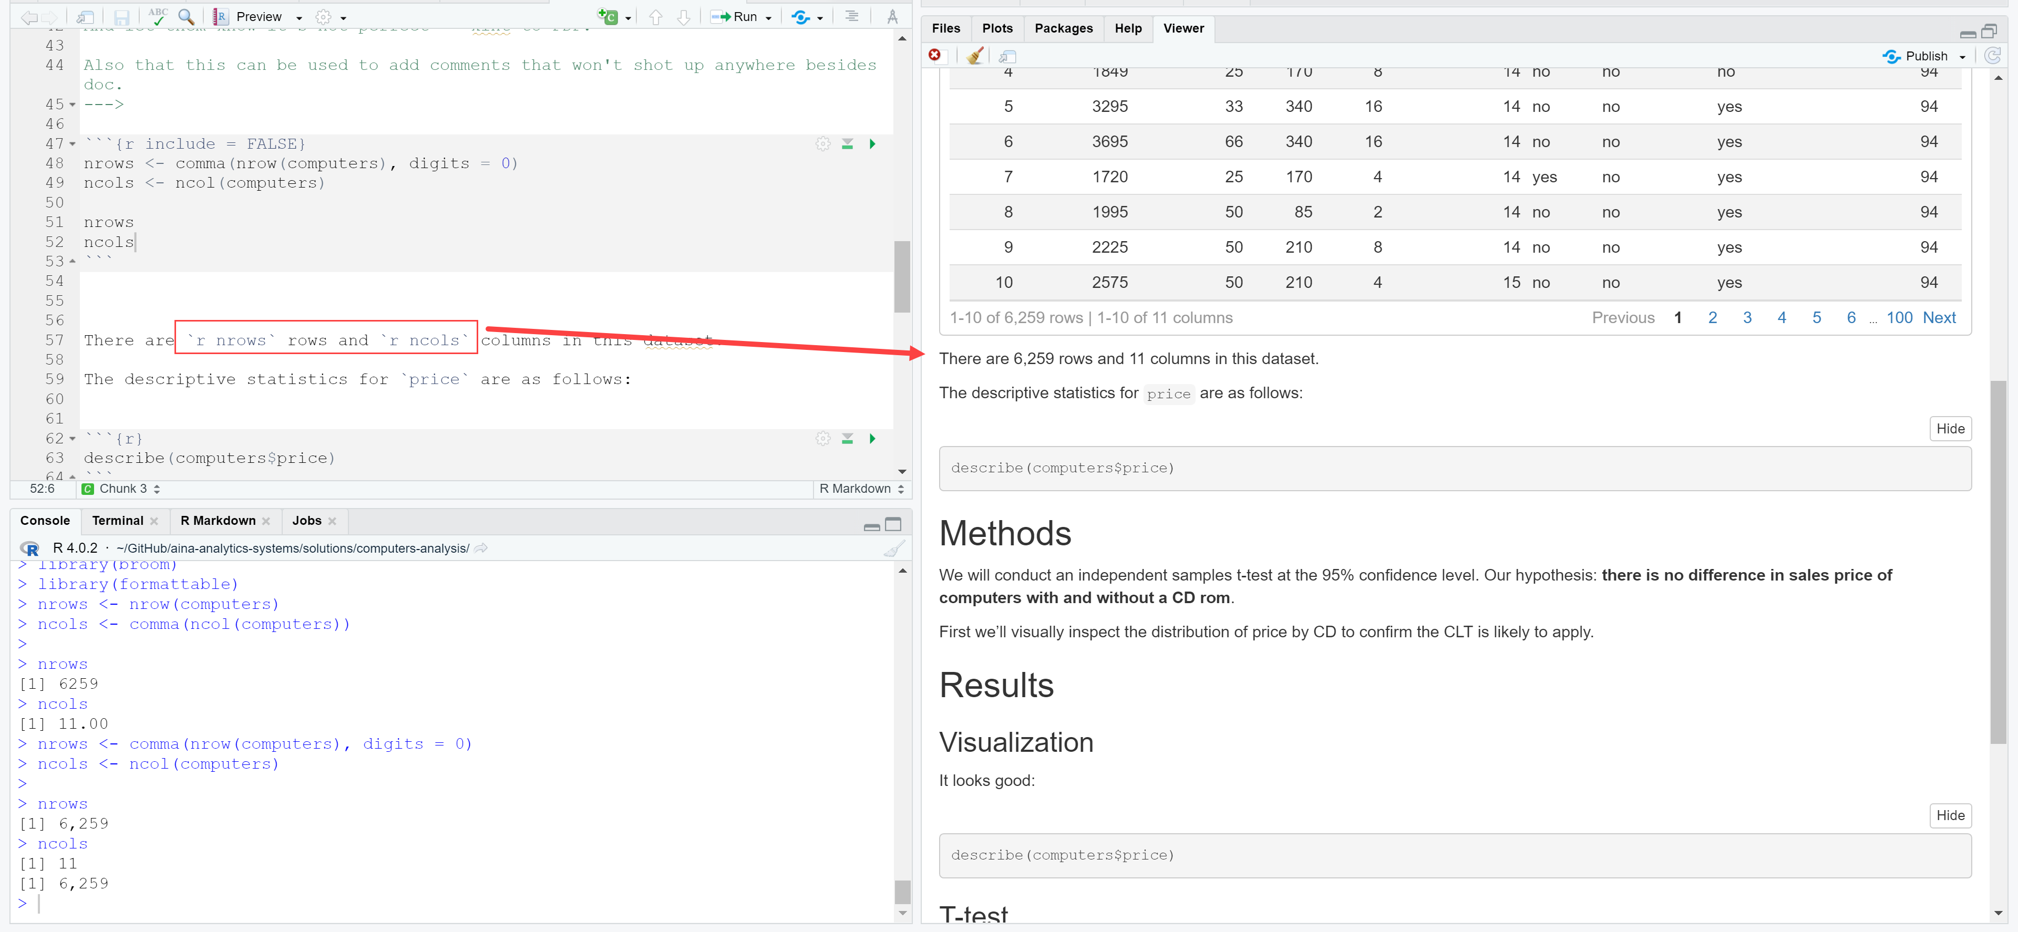
* You can add text-only comments that aren’t rendered in the doc or run by R by using the following notation (comes from HTML):

<!---

Comments go b/w the lines

--->

They’ll look like this in the notebook:

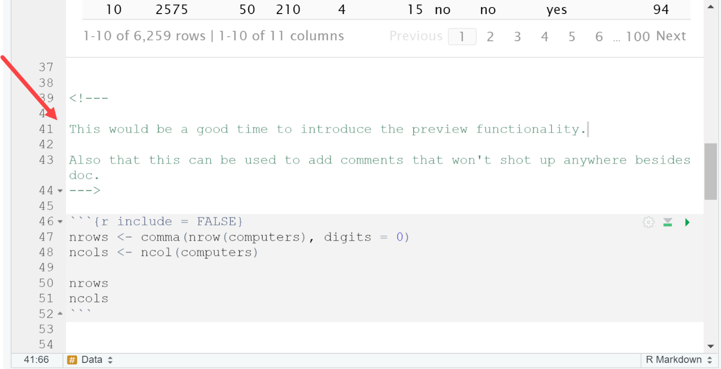

* If you’re just looking to try out some code before including it in the document, try using the console:  
  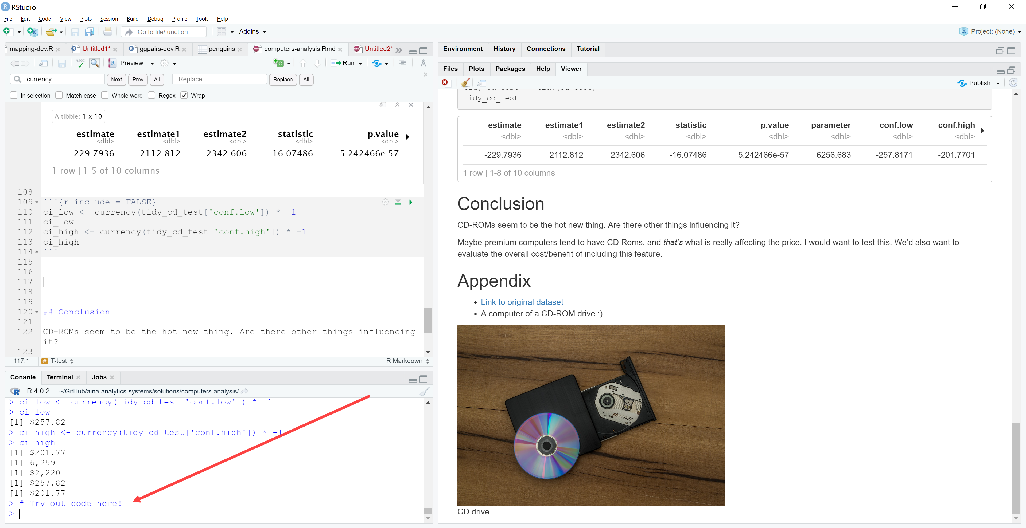
* If you are having an issue with changes to your document not being shown in preview, there is likely an error with your notebook causing it not to build properly. Check the header of your doc for an error message or knit the file to get further details.  
  